Information and Communication Technologies
Name: Joseph Tierney | Course: Computer Science
Module: Communications (G20001) | Tutor: Ulrike McMahon

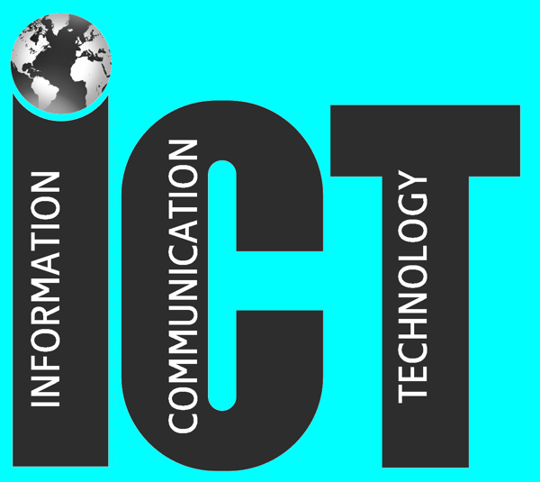

Contents
- Introduction
- Advantages of ICT in a Business
- Disadvantages of ICT in a Business
- Advantages of ICT in Society
- Disadvantages of ICT in Society
- Reccomendations
- Conclusion

1 Introduction
Information and Communication Technologies, commonly known as “ICT”, refers to technologies that provide access to information through means of telecommunications.
ICT has alternated the way in which we work, shop and spend our free time. While it may have improved life in a variety of different ways, we need to wary about how we use it. Spending hours upon hours at a computer can have a significance on our health and safety, and it's very easy to spend a lot of money without thinking. This report will examine the advantages and disadvantages of using Information and Communication Technology in businesses and in society in general, and it will draw recommendations regarding the disavantages that are brought up.

2 Advantages of ICT in Businesses
As businesses attempt to keep being competitive in the global markets, there are many advantages introducing ICT into the workplace. Productivity will see a huge up rise in working environments. With new technology being implemented into working environments, productivity should see a huge growth, as certain, if not all, activities will see a significant boost in completion.

Along with productivity, quality and accuracy will see a huge improvement with the addition of ICT in the workplace. Human error plays a huge part in organizations, but machines and technology will be able to replace some of the workload and tasks that humans need to do, as machines are suited to produce the same standard of product all the time, which in turn will lower the rate of human error.

Introducing ICT into a business can also improve communications with that business, and to an external extent, even its customers. Through the use of new technology such as email and video conference calls through Skype, communications between local branches or even between countries will be massively improved. Instead of using flights and accommodation, holding a video conference can and will save money. Thanks to ICT, the world's economy has become a single interdependent system. With this, we can share information readily and swiftly, but we can also bridge the cultural gap. With ICT, countries like Ireland and Japan, which are separated by distance and by language are able to share ideas, thoughts and information with each other without any trouble.

3 Disadvantages of ICT in Businesses
However, with advantages come certain disadvantages.

Financially, if a business were to buy brand new equipment, the equipment is normally expensive, and maintenance costs for multiple computers will be extremely high, causing the business to lose money in the process. Machinery and equipment can also undergo breakdowns, which in turn affects the production and continuation of work in the business.

ICT can replace some employees’ jobs, which can demoralize the staff and their motivation may suffer with this. As a result of this de-skilling of their job, workers can feel they are vulnerable to becoming redundant.

4 Advantages of ICT in Society
As with businesses, introducing Information and Communication Technology to society has a wide range of advantages.
With ICT,

Advantages:
Information when you want it, how you want it
Keeping in touch - less isolation
Financial opportunity - ie Internet shopping, online banking, share trading,
Medical advantages, ITC has massively speeded up diagnosis and treatment eg MRI scanners etc
Disadvantages:
Can CAUSE isolation - kids spend long hours on PC not interacting socially
Loss of family life - no sitting round the dinner table anymore
Information overload and stress - too much info, to quick
Kids have access to inappropriate material on the Internet - very BIG problem

5 Disadvantages of ICT in Society

